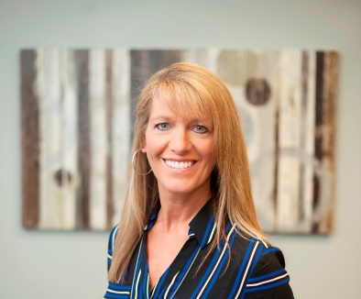
Michelle Corrao is a nationally known speaker with eleven years’ experience speaking to many different audiences. She shares her story to promote awareness and the debilitating effects of sexual violence. She brings a powerful message that addresses the pain and experience that victims of violent crimes endure and the way she overcame her brutal ordeal, learned to cope and survive. She led the efforts in creating a Sexual Assault Response Team (SART) for Adults and Pediatrics focusing on a victim centered response. Her message conveys a journey of resilience, inspiration, determination and hope.
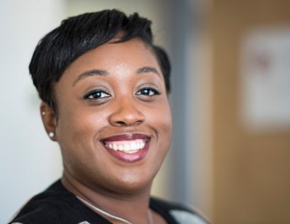

Miriam Lacroix is the daughter of a Haitian immigrant. Committed to helping immigrants stems from her father’s experience with the US immigration system. While she was a student attorney at the Immigration Justice Clinic, she represented a range of clients including girls from Senegal seeking to avoid genital mutilation and forced marriage. After graduation, she and Stephanie Lynn Ramos, Esq. founded Lacroix Ramos, LLP, a boutique law firm dedicated to providing family and humanitarian-based legal immigration services to small business owners, victims of intimate partner violence and other serious crimes, migrant children, and LGBT families.

Emma Kaywin is a sexual health educator and activist based in Brooklyn, NY. She is the consent co-lead for Meso Creso and the consent and safety lead for Ecstatic Dance NYC. Through these and other roles, Emma delivers consent and sexual safety workshops to individuals nationwide. She is currently working towards a doctorate in health education at Columbia Teachers College, where she is focusing on how to better educate youth in the necessary skills for healthy relationships.

PRIDE BEAUTY GALA

Guest Speakers


CHANGING FUTURES STAFF
Sadie Mahoney | Chief Officer of Youth and Family Services
Noris DeJesus Petrone | Program Director
Sagrario Garcia | Administrative Assistant
Lisette Abreu | Community Coordinator
Cassandra Glantz | Supervising Therapist
Zak Anolic | Supervising Therapist
Wendy Padilla | Bilingual Child & Family Therapist
Jaimenys Taveras | PT Bilingual Therapist
Deborah Lacroix | Child & Family Therapist
Johnna Jackson | CFP-Intern
Dorca Torres | CFP-Intern
Mary Toth | E.I.E Coordinator
Lauren McKeiver | Receptionist





